- Labeled Diagram: Desktop PC Components:

SSD
HDD
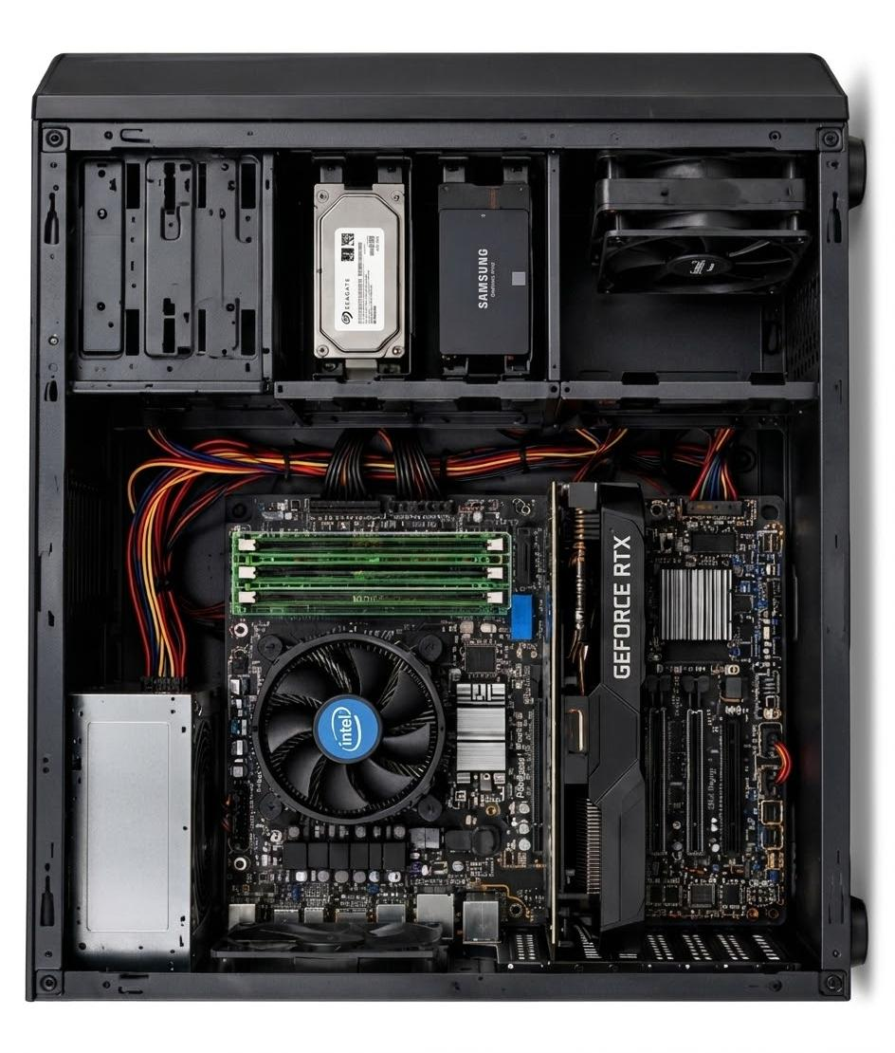
POWER SUPPLY
COOLER
CASE FAN
SATA
RAM
GPU

OTHER PORTS
CPU
MOTHERBOARD

2. HDD vs SSD Comparison:
Feature | HDD | SSD
Speed | Slower | Much faster
Durability | Less shock-resistant because it has moving parts  More shock-resistant because it has no moving parts | More shock-resistant because it has no moving parts
Storage Capacity | Usually available in larger capacities at lower cost | Usually more expensive per GB
Typical Use | Bulk storage, backups, large files | Operating system, games, applications
Noise | Makes some mechanical noise | Silent
Example | Desktop storage and backups | Laptops and gaming PCs

- Role of CPU, RAM and GPU in a Game:
CPU:
The CPU processes game instructions, player actions, physics, and other calculations. A powerful CPU helps the game run smoothly and reduces processing delays.
RAM:
RAM temporarily stores the game data and other information currently being used. More RAM allows the game and background applications to run smoothly with fewer slowdowns.
GPU:
The GPU renders graphics such as characters, textures, lighting, and effects. A powerful GPU provides better visual quality and higher FPS in games like PUBG or Free Fire.

4. Hardware Upgrades for Running the Latest FIFA Smoothly:
Component | Upgrade | Reason
GPU | Upgrade to a newer/better graphics card | Improves graphics quality and provides smoother gameplay with higher FPS.
CPU | Upgrade to a faster processor | Handles game calculations, physics, AI, and other processing tasks more efficiently.
RAM | Increase RAM to 16 GB or more | Provides enough memory for the game, Windows, and background applications.
SSD | Install or upgrade to an SSD | Reduces game loading times and improves overall system responsiveness.
Power Supply (PSU) | Upgrade if required | A more powerful GPU may require a higher-capacity power supply.
Cooling System | Improve cooling if necessary | Helps prevent overheating during long gaming sessions.

